The title of your conference paper goes here
[(Use Microsoft Word template style: Article Title) or (Use Times New Roman Font: 14 pt, Bold). Capitalise first letter of any proper nouns. When complete, delete all blue text between square brackets.]
Author’s Nameª and Author’s Name^{b}
[(Use Microsoft Word template style: Author Names) or (Use Times New Roman Font: 14 pt) (Names should be written in First Name Surname order)]
ªFirst Author Department Name, University or Organisation Name, City, Country; ^{b}Second Author Department Name, University or Organisation Name, City, Country
[(Use Microsoft Word template style: Affiliation) or (Use Times New Roman Font: 12 pt) (Author Affiliation should appear in the following order: Department Name, University Name, City, Country) (Authors’ affiliations are the affiliations where the research was conducted).]
ªFirst Author correspondence details, including e-mail, ORCiD, social media handles
^{b}Second Author correspondence details, including e-mail, ORCiD, social media handles
[(Use Microsoft Word template style: Correspondence details) or (Use Times New Roman Font: 12 pt) (Where available, please also include ORCiDs and social media handles (Facebook, Twitter, LinkedIn). (One author will need to be identified as the corresponding author, with their email address displayed in the published conference abstracts)]
Abstract: Type or paste your abstract here, with a maximum of 300 words. This is your opportunity to ‘pitch’ your article to the conference programme committee, and later, to readers. Your abstract should focus on what your research is about, what methods have been used, and what you found out. Abstracts and keywords help authors discover your research once published. When writing an abstract and selecting keywords, think carefully about reader expectation. You should always aim to accurately describe your research, but at the same time, try to do so in terms that are familiar to your target audience. Think about search queries that your intended audience is likely to be entering, why they would be searching for research, and how they would identify relevant research. Do not exceed the word limit of 300 words. [(To format your abstract, use Microsoft Word template style: Abstract or Use Times New Roman Font: 11 pt, Indent: Left 1.27cm, Right 1cm. Each paper must include an abstract. Begin with the word “Abstract” followed by a colon in bold font, then continue with normal 11-point font.)]
Keywords: word; another word; lower case except names; maximum of five (5).

Heading 1: first level headings should use this template style
[First-level headings (e.g., Introduction, Methods, Conclusion etc.) should be in bold, with an initial capital letter for any proper nouns.]
Type or paste the first paragraph of your conference paper here. The first paragraph after any heading or extract is not indented. Full papers should not exceed 3000 words (including all references, tables, and illustrations). In-text citations generally consist of the surname(s) of the author(s), the year of publication of the work cited, and page number(s) if necessary, enclosed within parentheses. For example: The most recent report (Smith, 2016) on the use of … If the author’s name forms part of the discussion, the parenthesis can be limited to the year of publication. For example: Smith (2016) found that the use of … [(Use Microsoft Word template style: Paragraph) or (Use Times New Roman Font: 12pt, double line spacing) (Reference guide on page 5).]
After the first paragraph, other paragraphs will have the first line indented. Using template style Paragraph will automatically indent the first line of subsequent paragraphs. [(Use Microsoft word template style Paragraph) or (Use Times New Roman Font: 12pt, double line spacing, first line indented by 1.25cm)]

Heading 2: second level headings should use this template style
After the second level heading, the paragraph format will follow the same format as above. The first paragraph after any heading or extract is not indented.
After the first paragraph, other paragraphs will have the first line indented. Using template style Paragraph will automatically indent the first line of subsequent paragraphs. [(Use Microsoft word template style Paragraph) or (Use Times New Roman Font: 12pt, double line spacing, first line indented by 1.25cm)]

Heading 3: third level headings should use this template style
Additional formatting requirements can be seen below, along with templated styles that can be accessed by using Microsoft Word styles in the ribbon above. Shortcuts for template styles in this document can be accessed using Alt + Ctrl + Shift + S, or by clicking the pop out arrow in the editing ribbon to open the style window.
If you have long quotations of over 40 words, they should be displayed as indented text, without quotation marks. Use the template style displayed quotation. For shorter quotations, use single quotation marks, expect where there is ‘a quotation “within” a quotation’. [(Use Microsoft Word template style: displayed quotation) or (Use Times New Roman Font: 11pt, line spacing: 1.5, indentation left: 1.25cm right 0.75cm)]
- For bulleted lists, use Microsoft Word template style bulleted list
- Bulleted lists look like this
- Bullet number three
- For numbered lists, use Microsoft Word template style numbered list
- Numbered lists look like this
- Bullet number three
Heading 4: Figures and tables. Figures and tables should be inserted in your article text and should be placed soon after their first reference in the text. All figures and tables should be numbered consecutively with Arabic numerals.
- Tables should present new information rather than duplicating what is in the text. Readers should be able to interpret the table without reference to the text, but ensure you refer to each table in the text.
- You may be asked to send your original, editable files (e.g., MS Word or Excel). Non-editable files (e.g., JPEG images, or images of text boxes in PowerPoint) are not suitable formats but can be included in addition for reference.
- Please present table titles separately for each table (format below), rather than including them as the first row of the table. Table notes should be separate from the titles and included underneath the table to which they apply.
- Due to the range and complexity of tables and figures, we only offer an example for guidance. Please follow the style template for table (and figure) captions.
- Obtain permission and include the acknowledgement required by the copyright holder if a table is being reproduced from another source. View guidance.
Table 1. Type your title here. [(Use Microsoft Word template style: Table title)]
Column Title | Column Title | Column Title | Column Title
Row Name
Row Name
Row Name
Figure 1. Type your caption here. [(Use Microsoft Word template style: Table title)]
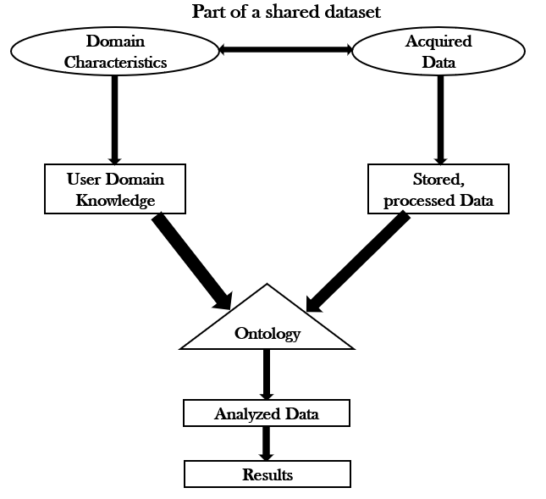

Equations
If you are submitting your manuscript as a Word document, please ensure that equations are editable. More information about mathematical symbols and equations.

Units
Please use SI units (non-italicized).

Conclusion
Conclusions should state concisely the most important propositions of the paper as well as the author’s views of the practical implications of the results.

Acknowledgement
A short acknowledgement section can be written between the conclusion and the references. Sponsorship and financial support acknowledgments should be included here. Acknowledging the contributions of other colleagues who are not included in the authorship of this paper is also added in this section. If no acknowledgement is necessary, this section should not appear in the paper.

References
List of references for all sources that have been cited in the text. [(Use Microsoft Word template style: References)]
APA (American Psychological Association) style referencing should be used. Place references in alphabetical order by the surname of the first author followed by the initials of the author’s given name.
Follow the APA 6th Edition style guide for all references, includes examples for intext references and reference format by type of publication.

Author, A. A. (Year). Title of article: And subtitle. Journal Title, volume(issue), pages.
Author, A. A. (Year). Title of book: And subtitle. Place: Publisher.
Author, A. A. (Year). Title of work (Report No. xxx). Place: Institution.

Special characters
If you are preparing your manuscript in Microsoft Word and your article contains special characters, accents, or diacritics, we recommend you follow these steps:
- European accents (Greek, Hebrew, or Cyrillic letters, or phonetic symbols): choose Times New Roman font from the dropdown menu in the “Insert symbol” window and insert the character you require.
- Asian languages (such as Sanskrit, Korean, Chinese, or Japanese): choose Arial Unicode font from the dropdown menu in the “Insert symbol” window and insert the character you require.
- Transliterated Arabic: choose either Times New Roman or Arial Unicode (unless the instructions for authors specify a particular font). For ayns and hamzas, choose Arial Unicode font from the dropdown menu in the “Insert symbol” window. Type the Unicode hexes directly into the “Character code” box, using 02BF for ayn, and 02BE for hamza.

Final points to consider
- Write and prepare your article using this CDRI Conference Paper Template.
- During final submission, create a PDF file of your paper (making sure to embed all fonts).
- Send the following items to your conference organizer:
  - MS Word version of your article, as well as the PDF version. It will help us track any formatting change during upload.
  - (If it applies) Copies of any permissions to re-use copyrighted materials in your article (e.g., figures from books/journals)
We require both MS Word File and PDF for peer review to keep track of font distortion. After acceptance of a manuscript, we ask all authors to carefully check the final version of article PDF prior to submission. Perform visual inspections to detect subtle font errors and ensure that all fonts are embedded. To ensure that readers can display and print your paper correctly across a range of devices and applications, it is important that the PDF file is portable and self-contained.
Here’s how to add fonts to your PDF doc the easy way.
- Check to see which fonts are embedded by opening document properties.
- Find your font: To embed fonts that are not already embedded, go to File > Print. Bring up Adobe PDF settings and properties, then Adobe PDF settings.
- Embed your font: Edit the default settings and navigate to Font, click the Embed all fonts option. Your font should now be installed for use.
- For more detail visit: Adobe website.

Summary Checklist
- Full papers should not exceed 3000 words (including all references, tables, and figures).
- Articles should use the single column CDRI Conference Paper template, including the correct heading and paragraph styles.
- Use Times New Roman font, the point size will vary by section.
- Do not alter the margins of the template. Altering them can cause significant delays. Paper size should be A4 (width: 21cm, height: 29.7cm) with margins set at: Top: 2.5cm, Left: 3cm, Bottom: 2.5cm, Right: 3cm.
- Do not include any headers, footers, or page numbers in your document, or amend this template in any way.
- Make sure all author affiliation associations are correct. This means author vs. affiliation and author vs. email address. If there is only one affiliation for all authors, association is not needed. Author names should be listed in First name Surname format.
- Use clear, legible tables, graphics and diagrams.
- Do not use copyrighted material without permission. Papers using copyrighted material without appropriate permission and acknowledgment will be excluded from publication.
- Prepare and format references with care according to APA guidelines.
- Embed all fonts into your article PDF. PDFs supplied without embedded fonts may be returned which can cause unnecessary inconvenience and publication delays for other authors. Failure to provide a replacement paper in a timely fashion may result in an article being removed.
- Check your article PDF. It is not uncommon for errors to appear in PDFs generated from Microsoft Word.
- Avoid large Word/PDF files (10 MB maximum, ideally).

Annexure I
Format for Responding to Peer Review Comments (for Peer Review only)
At the time of submitting the first version of full draft of manuscript, the author(s) must submit response/justification for the comments received during the peer review of the abstracts.
Reviewers’ Comments | Response by author(s) | Remarks by authors
Please split the comments if it helps in better response. | Write your response to these comments here. | If the additional information is added in the manuscript with respect to comment, please indicate sections/page number where these responses have been incorporated in the manuscript.
Use more lines if required.

